**Chapter 1**

**Introduction**

1.1 Introduction

The Cloud Computing model introduces several benefits for applications and enterprises. The adaptive management of the Cloud allows applications to scale on demand according to their needs: applications can dynamically acquire more resource to host their services in order to handle peak workloads and release when the load decreases. Enterprises do not have to plan for the peak capacity anymore, but they can provision as many resources as they need, for the time they need, and when they need. Moreover, by moving their IT infrastructure into the Cloud, enterprise can reduce their administration and maintenance costs. This opportunity becomes even more appealing for startups, which can start their business with a small capital and increase their IT infrastructure as their business grows. This model is also convenient for service providers that can maximize the revenue from their physical infrastructure. Besides the most common “pay as you go” strategy more effective pricing policies can be devised according to the specific services delivered to the end user. The use of virtualization technologies allows a fine control over the resources and the services that are made available at runtime for applications. This introduces the opportunity of adopting various pricing models that can benefit either the customers or the vendors. The model endorsed by Cloud Computing provides the capability of leveraging the execution of applications on a distributed infrastructure that, in case of public clouds, belongs to third parties. While this model is certainly convenient, it also brings additional issues from a legal and a security point of view. For example, the infrastructure constituting the Computing Cloud can be made of datacenters and clusters located in different countries where different laws for digital content apply. The same application can then be considered legal or illegal according to the where is hosted. In addition, privacy and confidentiality of data depends on the location of its storage. For example, confidentiality of accounts in a bank located in Switzerland may not be guaranteed by the use of data center located in United States. In order to address this issue some Cloud Computing vendors have included the geographic location of the hosting as a parameter of the service level agreement made with the customer. For example, Amazon EC2 provides the concept of availability zones that identify the location of the datacenters where applications are hosted. Users can have access to different availability zones and decide where to host their applications. Since Cloud Computing is still in its infancy the solutions devised to address these issues are still being explored and will definitely become fundamental when a wider adoption of this technology takes place.

1.2 Motivation

Cloud computing is a recently developing new technology for complex systems with massive scale service sharing, which is different from the resource sharing of the grid computing systems. A paradigm shift to cloud computing will affect many different sub-categories in computer industry such as software companies, internet service providers (ISPs) and hardware manufacturers. While it is relatively easy to see how the main software and internet companies will be affected by such a shift, it is more difficult to predict how companies in the internet and hardware sectors will be affected. Cloud reliability and modeling are not easy tasks because of the complexity, sharing resources present at far locations and large scale of the system. Various types of failures are interleaved in the cloud computing environment, such as overflow failure, timeout failure, and resource missing failure, network failure, hardware failure, software failure, and database failure. In current scenario sectors like banking and others are still using the traditional way (servers) and are not using cloud the reliability of cloud due to security and performance. The purpose of our project is to find a way to make cloud more secure to use for the sectors other than IT by making a research in security domain. The implementation of cloud will aim at reduced cost, centralization of data, scalability, monitoring of performance, improvements for systems that are often only 10–20% utilized. In short the affects of shifting completely to the cloud will affect the entire industry and more.[9]

The cloud computing concerns involve computer and network intrusions or attacks that will be made possible or at least easier by moving to the cloud. Figure 1.1 shows various cloud challenges and issues which are of high concern. [3,7] Cloud providers respond to these concerns by arguing that their security measures and processes are more mature and tested than those of the average company. Another argument, made by the Jericho Forum, is: "It could be easier to lock down information if it's administered by a third party rather than in-house, if companies are worried about insider threats. In addition, it may be easier to enforce security via contracts with online services providers than via internal controls."

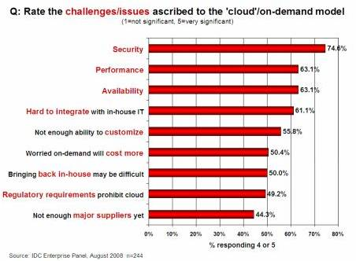

Fig. 1.1 Challenges and Issues in cloud computing

With the advancement of the modern human society, basic and essential services are delivered almost to everyone in a completely transparent manner. Utility services such as water, gas, and electricity have become fundamental for carrying out our daily life and are exploited on a pay per use basis. The existing infrastructures allow delivering such services almost anywhere and anytime so that we can simply switch on the light, open the tap, and use the stove. The usage of these utilities is then charged, according to different policies, to the end user. Recently, the same idea of utility has been applied to computing and a consistent shift towards this approach has been done with the spread of Cloud Computing. This report presents the cloud computing environment with the safety issues and performance through analyzing a cloud computing framework.

1.3 Process Adopted

There are signiﬁcant technical, operational and organizational issues which need to be tackled before clouds are used extensively at the enterprise level.[8] Performance and security issues are yet under the roof of surveillance. In our project we used Manjrasoft Aneka 2.0 which is a .Net based framework for cloud computing. We monitored the performance of our cloud by varying number of applications and changing the cloud resource configuration. For security issues we proposed two solutions. One is the multiple encryptions of data before sending to cloud and second is the Stegnocrypt which enhances security of data by first encrypting it and then hiding the encrypted Cipher text into an Image. Using NetBeans we have implemented the multiple encryption on Ceaser Cipher.

1.4 Summary of work

Development in field of cloud computing is at a great pace thus security and performance issues has become a top priority from customer and providers perspective. Our work explains all about cloud computing technology, its wide application areas and trends in them, cloud computing environment with the security issues and performance through analyzing a cloud computing framework-Aneka. Different experimentations have been done by varying the cloud configuration and performance being monitored. We propose solutions to deal with security issues which are Multiple Encryption and Stegnocrypt techniques. Finally we implement a multiple encryption Ceaser cipher algorithm for data security.

**Chapter 2**

**Literature Survey**

2.1 What is Cloud Computing?

Many people are confused as to exactly what cloud computing is, especially as the term can be used to mean almost anything. Roughly, it describes highly scalable computing resources provided as an external service via the internet on a pay-as-you-go basis. The cloud is simply a metaphor for the internet, based on the symbol used to represent the worldwide network in computer network diagrams.[2]

Economically, the main appeal of cloud computing is that customers only use what they need, and only pay for what they actually use. Resources are available to be accessed from the cloud at any time, and from any location via the internet. There’s no need to worry about how things are being maintained behind the scenes – you simply purchase the IT service you require as you would any other utility. Because of this, cloud computing has also been called utility computing, or ‘IT on demand’. [4]

This new, web-based generation of computing utilizes remote servers housed in highly secure data centers for data storage and management, so organizations no longer need to purchase and look after their IT solutions in-house. [1,10,11]

2.2 Components of Cloud Computing

Cloud computing can be visualized as a pyramid consisting of three sections as shown below in figure 2.1:

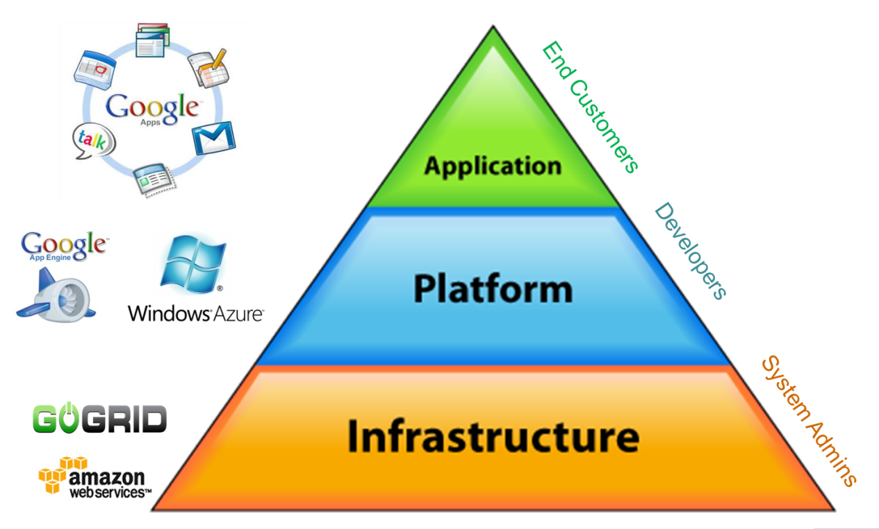

Fig. 2.1 Cloud Pyramid

Cloud Application

This is the apex of the cloud pyramid, where applications are run and interacted with via a web browser, hosted desktop or remote client. A hallmark of commercial cloud computing applications is that users never need to purchase expensive software licenses themselves. Instead, the cost is incorporated into the subscription fee. A cloud application eliminates the need to install and run the application on the user desktop, thus removing the burden of software maintenance, ongoing operation and support.

Cloud Platform

The middle layer of the cloud pyramid, which provides a computing platform or framework as a service. A cloud computing platform dynamically provisions, configures, reconfigures and de-provisions servers as needed to cope with increases or decreases in demand. This in reality is a distributed computing model, where many services pull together to deliver an application or infrastructure request.

Cloud Infrastructure

The foundation of the cloud pyramid is the delivery of IT infrastructure through virtualization. Virtualization allows the splitting of a single physical piece of hardware into independent, self governed environments, which can be scaled in terms of CPU, RAM, Disk and other elements. The infrastructure includes servers, networks and other hardware appliances delivered as Infrastructure “Web Services”, “farms” or "cloud centers". These are then interlinked with others for resilience and additional capacity. [1,9,10]

2.3 Types of Clouds

Public Cloud:

Public cloud describes the conventional meaning of cloud computing: scalable, dynamically provisioned, often virtualized resources available over the Internet from an off-site third- party provider, which divides up resources and bills its customers on a ‘utility’ basis.

Private Cloud:

Private cloud (aka ‘corporate’ or ‘internal’ cloud) is a term used to denote a proprietary computing architecture providing hosted services on private networks. This type of cloud computing is generally used by large companies, and allows their corporate network and data centre administrators to effectively become in-house ‘service providers’ catering to ‘customers’ within the corporation. However, it negates many of the benefits of cloud computing, as organizations still need to purchase, set up and manage their own clouds.

Hybrid Cloud:

It has been suggested that a hybrid cloud environment combining resources from both internal and external providers will become the most popular choice for enterprises. For example, a company could choose to use a public cloud service for general computing, but store its business-critical data within its own data centre. [10,11]

2.4 Services offered by cloud computing

There are numerous services that can be delivered through cloud computing, taking advantage of the distributed cloud model. Here are some brief descriptions of a few of the most popular cloud-based IT solutions:

**Hosted Desktops:** Hosted desktops remove the need for traditional desktop PCs in the office environment, and reduce the cost of providing the services that you need. A hosted desktop looks and behaves like a regular PC, but the software and data customers use are housed in remote, highly secure data centers, rather than on their own machines. Users can simply access their hosted desktops via an internet connection from anywhere in the world, using either an existing PC or laptop or, for maximum cost efficiency, a specialized device called a thin client.

**Hosted Email:** As more organizations look for a secure, reliable email solution that will not cost the earth, they are increasingly turning to hosted Microsoft Exchange® email plans. Using the world’s premier email platform, this service lets organizations both large and small reap the benefits of using MS Exchange® accounts without having to invest in the costly infrastructure themselves. Email is stored centrally on managed servers, providing redundancy and fast connectivity from any location. This allows users to access their email, calendar, contacts and shared files by a variety of means, including Outlook®, Outlook Mobile Access (OMA) and Outlook Web Access (OWA).

**Hosted Telephony (VOIP):** VOIP (Voice Over IP) is a means of carrying phone calls and services across digital internet networks. In terms of basic usage and functionality, VOIP is no different to traditional telephony, and a VOIP-enabled telephone works exactly like a 'normal' one, but it has distinct cost advantages. A hosted VOIP system replaces expensive phone systems, installation, handsets, BT lines and numbers with a simple, cost-efficient alternative that is available to use on a monthly subscription basis. Typically, a pre-configured handset just needs to be plugged into your broadband or office network to allow you to access features such as voicemail, IVR and more.

**Cloud Storage:** Cloud storage is growing in popularity due to the benefits it provides, such as simple, CapEx-free costs, anywhere access and the removal of the burden of in-house maintenance and management. It is basically the delivery of data storage as a service, from a third party provider, with access via the internet and billing calculated on capacity used in a certain period (e.g. per month).

**Dynamic Servers:** Dynamic servers are the next generation of server environment, replacing the conventional concept of the dedicated server. A provider gives its customer’s access to resources that look and feel exactly like a dedicated server, but that are fully scalable. You can directly control the amount of processing power and space you use, meaning you don't have to pay for hardware you don't need. Typically, you can make changes to your dynamic server at any time, on the fly, without the costs associated with moving from one server to another.

2.5 Why switch from traditional IT to the cloud?

There are many reasons why organizations of all sizes and types are adopting this model of IT. It provides a way to increase capacity or add capabilities on the fly without investing in new infrastructure, training new personnel, or licensing new software. Ultimately, it can save companies a considerable amount of money...

**Removal / reduction of capital expenditure:** Customers can avoid spending large amounts of capital on purchasing and installing their IT infrastructure or applications by moving to the cloud model. Capital expenditure on IT reduces available working capital for other critical operations and business investments. Cloud computing offers a simple operational expense that is easier to budget for month-by-month, and prevents money being wasted on depreciating assets. Additionally, customers do not need to pay for excess resource capacity in-house to meet fluctuating demand.

**Reduced administration costs:** IT solutions can be deployed extremely quickly and managed, maintained, patched and upgraded remotely by your service provider. Technical support is provided round the clock by reputable providers like ThinkGrid for no extra charge, reducing the burden on IT staff. This means that they are free to focus on business-critical tasks, and businesses can avoid incurring additional manpower and training costs. IT giant IBM has pointed out that cloud computing allows organizations to streamline procurement processes, and eliminates the need to duplicate certain computer administrative skills related to setup, configuration, and support.

**Improved resource utilization:** Combining resources into large clouds reduces costs and maximizes utilization by delivering resources only when they are needed. Businesses needn’t worry about over-provisioning for a service whose use does not meet their predictions, or under-provisioning for one that becomes unexpectedly popular. Moving more and more applications, infrastructure, and even support into the cloud can free up precious time, effort and budgets to concentrate on the real job of exploiting technology to improve the mission of the company. It really comes down to making better use of your time – focusing on your business and allowing cloud providers to manage the resources to get you to where you need to go. A side effect of this approach is that computer capacity rises dramatically, as customers do not have to engineer for peak loads.

**Economies of scale:** Cloud computing customers can benefit from the economies of scale enjoyed by providers, who typically use very large-scale data centres operating at much higher efficiency levels, and multi-tenant architecture to share resources between many different customers. This model of IT provision allows them to pass on savings to their customers.

**Scalability on demand:** Scalability and flexibility are highly valuable advantages offered by cloud computing, allowing customers to react quickly to changing IT needs, adding or subtracting capacity and users as and when required and responding to real rather than projected requirements. Even better, because cloud-computing follows a utility model in which service costs are based on actual consumption, you only pay for what you use. Customers benefit from greater elasticity of resources, without paying a premium for large scale.

**Quick and easy implementation:** Without the need to purchase hardware, software licenses- or implementation services, a company can get its cloud-computing arrangement off the ground in minutes.

**Helps smaller businesses compete:** Historically, there has been a huge disparity between the IT resources available to small businesses and to enterprises. Cloud computing has made it possible for smaller companies to compete on an even playing field with much bigger competitors. ‘Renting’ IT services instead of investing in hardware and software makes them much more affordable, and means that capital can instead be used for other vital projects.

**Quality of service:** Your selected vendor should offer 24/7 customer support and an immediate response to emergency situations.

**Anywhere Access:** Cloud-based IT services let you access your applications and data securely from any location via an internet connection. It’s easier to collaborate too; with both the application and the data stored in the cloud, multiple users can work together on the same project, share calendars and contacts etc. It has been pointed out that if your internet connection fails, you will not be able to access your data. However, due to the ‘anywhere access’ nature of the cloud, users can simply connect from a different location – so if your office connection fails and you have no redundancy, you can access your data from home or the nearest Wi-Fi enabled point. Because of this, flexible / remote working is easily enabled, allowing you to cut overheads, meet new working regulations and keep your staff happy!

**Technical Support:** A good cloud computing provider will offer round the clock technical support. Customers, for instance, are assigned one of our support pods, and all subsequent contact is then handled by the same small group of skilled engineers, who are available 24/7. This type of support model allows a provider to build a better understanding of your business requirements, effectively becoming an extension of your team.

**Disaster recovery / backup:** Recent research has indicated that around 90% of businesses do not have adequate disaster recovery or business continuity plans, leaving them vulnerable to any disruptions that might occur. Providers can provide an array of disaster recovery services, from cloud backup (allowing you to store important files from your desktop or office network within their data centers) to having ready-to-go desktops and services in case your business is hit by problems. Files are stored twice at different remote locations to ensure that there's always a copy available 24 hours a day, 7 days per week. [10,11,12]

**Chapter 3**

**Methodology**

3.1 Aneka Tool

Aneka[5] is a platform for deploying Clouds developing applications on top of it. It provides a runtime environment and a se1t of APIs that allow developers to build .NET applications that leverage their computation on either public or private clouds. One of the key features of Aneka is the ability of supporting multiple programming models that are ways of expressing the execution logic of applications by using specific abstractions. This is accomplished by creating a customizable and extensible service oriented runtime environment represented by a collection of software containers connected together. By leveraging on these architecture advanced services including resource reservation, persistence, storage management, security, and performance monitoring have been implemented. On top of this infrastructure different programming models can be plugged to provide support for different scenarios as demonstrated by the engineering, life science, and industry applications.

3.2 Aneka Daemon

The Aneka Daemon is responsible for managing Aneka Containers that make up our cloud. This includes installing new Containers, starting, stopping and uninstalling Containers. Aneka Daemons provide the underlying management infrastructure for Aneka Clouds. Figure 3.1 on the next page reveals the general architecture of Aneka Tool consisting of Daemons and Containers.

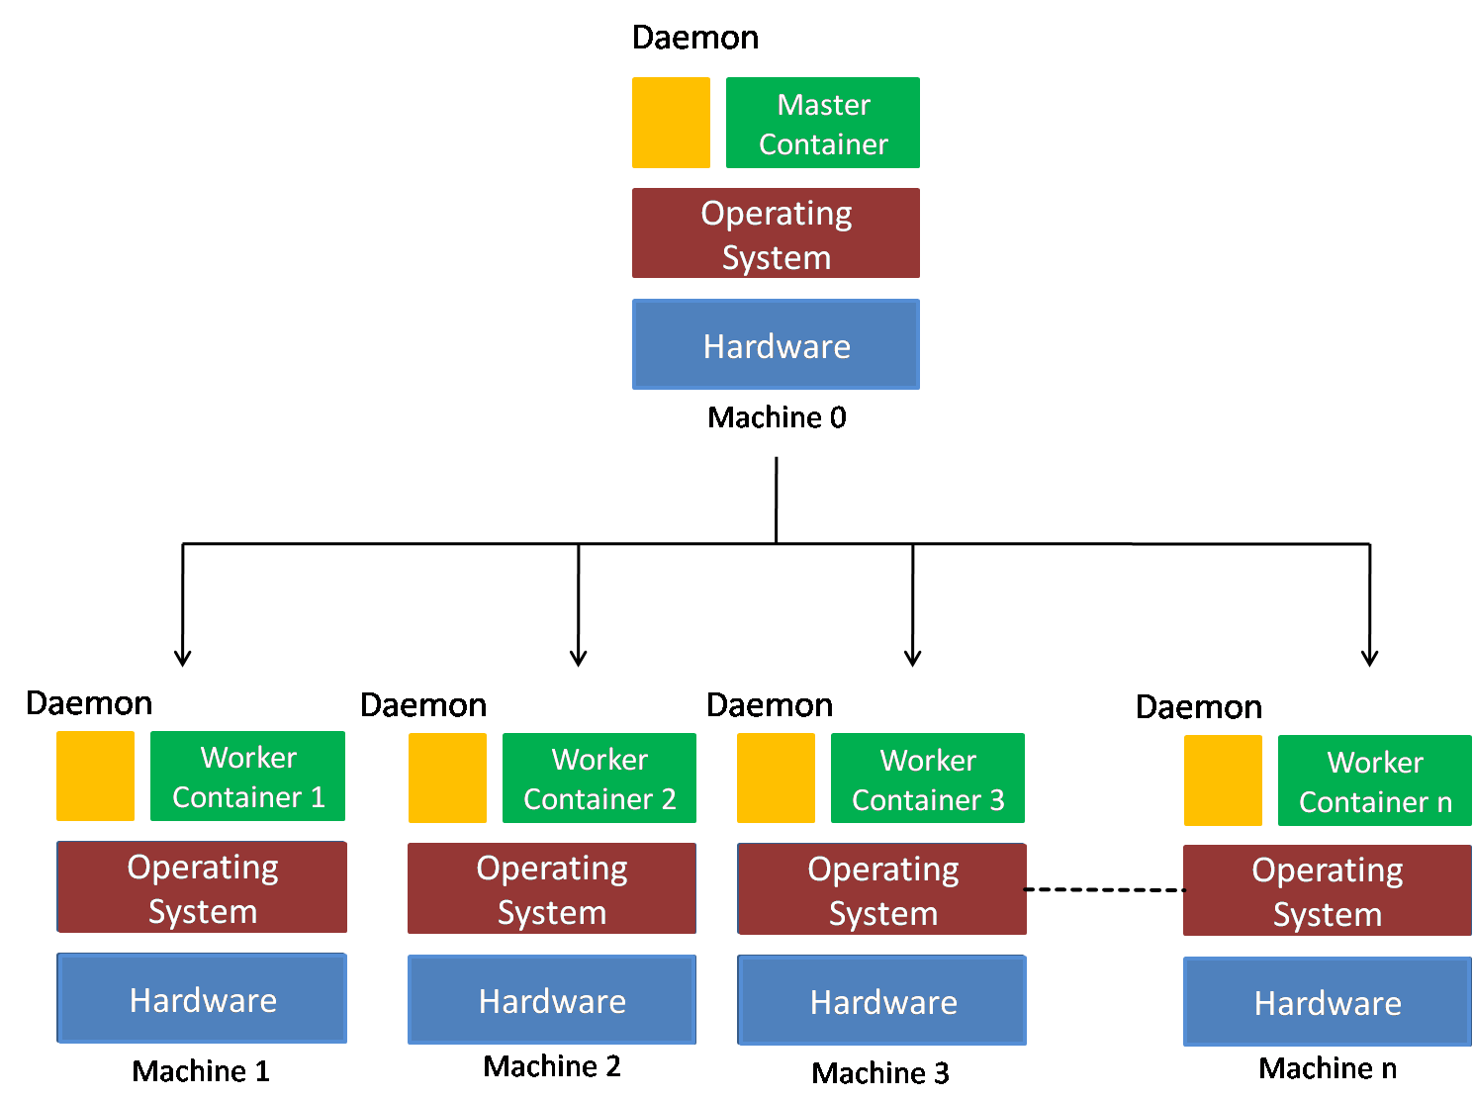

Fig. 3.1 Aneka Architecture

3.3 Aneka Containers

Once you have the Aneka Daemon running on all selected machines you are now ready to create an Aneka Cloud. As described earlier, an Aneka Cloud is composed of a *Master Container* and group of *Worker Containers*. All Workers are registered to the Master, which acts as a gateway to the Cloud. End-users submit their applications, composed of a number of jobs, to the Master which in turn schedules them to Workers.

To begin creating your cloud, you must first decide on the machine that will host the *Master Container*. Ideally, this must be a machine capable of processing requests from a number of clients while also managing a large number of Workers. The capability of this machine will of course depend on the size of your cloud and the expected usage.

3.4 Proposed Solutions

Multiple Encryption:

Multiple encryption is the process of encrypting an already encrypted message one or more times, either using the same or a different algorithm. The terms cascade encryption, cascade ciphering, multiple encryption, multiple ciphering, and superencipherment are used with the same meaning.

StegnoCrypt:

Steganography and Cryptography are two popular ways of sending vital information in a secret way. One hides the existence of the message and the other distorts the message itself. In Steganography we have various techniques in different domains like spatial domain, frequency domain etc. to hide the message. It is very difficult to detect hidden message in frequency domain. In this technique a system can be developed in which Cryptography and Steganography are used as integrated part along with newly developed enhanced security module.

3.5 Implemented Algorithm

x:=character read from the file

n:=is the number by which character is shifted

t:=number of times to encrypt

//Encryption

for(int i=1;i<=t;i++) {

if (character is in alphabet)

E(x)=x+n mod 26

else if(character is a number)

E(x)=x+n mod 10

else if(special character)

E(x)=x

}

//Decryption

for(int i=1;i<=t;i++)

{

if (character is in alphabet)

D(x)=x-n mod 26

else if(character is a number)

D(x)=x-n mod 10

else if(special character)

D(x)=x

}

3.6 System Analysis

The following diagrams show the over-all analysis of the system which implements the multiple encryptions on Ceaser cipher algorithm of data security.

The implemented system lets a user to choose a text file or a encrypted file and then prompts for number of times the user wants to run the encryption/decryption loop and with how many shifts for the Ceaser Cipher. The ecrypted/decrypted file is generated at the same place where the true/original file is kept.

3.6.1Use Case Diagram

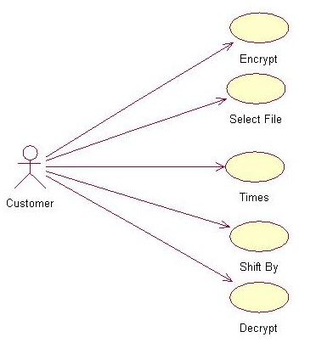

Fig. 3.6.1 Use Case diagram for Implemented Solution

3.6.2 Sequence Diagram

a. Encryption

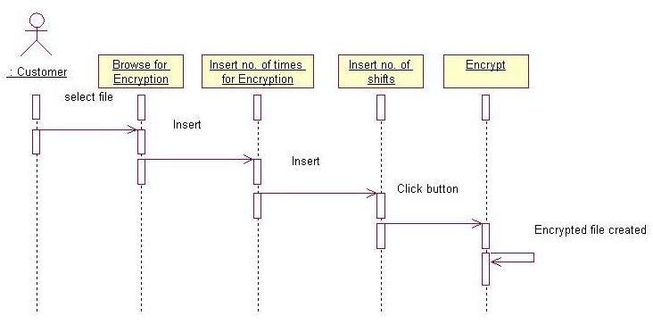

Fig. 3.6.2.1 Sequence Diagram Encryption

b. Decryption

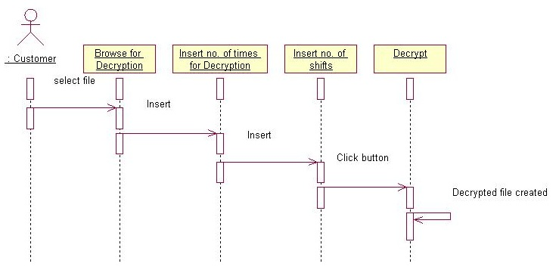

Fig. 3.6.2.2 Sequence Diagram Decryption

3.6.3 Activity Diagram

a. Encryption

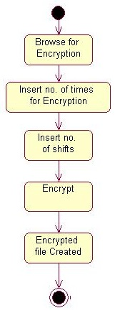

Fig.3.6.3.1 Activity Diagram Encryption

b. Decryption

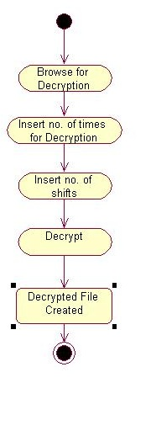

Fig.3.6.3.2 Activity Diagram Decryption

**Chapter 4**

**Experimentation and Results**

4.1 Aneka Tool

Aneka is a platform for deploying Clouds developing applications on top of it. It provides a runtime environment and a set of APIs that allow developers to build .NET applications that leverage their computation on either public or private clouds. One of the key features of Aneka is the ability of supporting multiple programming models that are ways of expressing the execution logic of applications by using specific abstractions. This is accomplished by creating a customizable and extensible service oriented runtime environment represented by a collection of software containers connected together. By leveraging on these architecture advanced services including resource reservation, persistence, storage management, security, and performance monitoring have been implemented. On top of this infrastructure different programming models can be plugged to provide support for different scenarios as demonstrated by the engineering, life science, and industry applications.

4.1.1 Management Studio

Aneka provides a platform on top of which it is possible to develop applications for the Cloud. The Software Development Kit addresses all the needs from a development point of view but it is just a part of the feature set required by a Cloud Computing platform. Essential in this case is the support for monitoring, managing, maintaining, and setting up computing clouds. These operations are exposed by the management API and the Platform Abstraction Layer on top of which all the management tools and interfaces have been designed. Of a particular interest are the Management Studio and the web management interfaces. The Management Studio is an important tool for system administrators. It is a comprehensive environment that allows them to manage every aspect of Aneka Clouds from an easy to use graphical user interface. Since Clouds are constituted of hundreds and even thousands of machines both physical and virtual,it is not possible to reach and setup each single machine by hand. Having a tool that allows remote and global management is then a basic requirement. Briefly, the set of operations that can be performed through the Management Studio are the following:

• Quick setup of computing clouds;

• Remote installation and configuration of nodes;

• Remote control of containers;

• System load monitoring and tuning.

Besides the remote control features, which dramatically simplify the management of the Cloud, it is important to notice the support for viewing the aggregate dynamic statistics of Aneka Clouds. This helps administrators to tune the overall performance of the Cloud. It is also possible to probe each single node and collect the single performance statistics: the CPU and memory load information is collected from each container and by inspecting the container configuration it is possible to identify bottlenecks in the Cloud. As the entire framework, the Management Studio has been designed to be extensible: it is possible to add new features and new services by implementing management plugins that are loaded into the environment and get access to the Cloud.

The Management Studio is not the only tool available for controlling Aneka Clouds. The framework also provides a set of web interfaces that provide a programmatic management of Aneka. Currently, only a restricted set of features – resource reservation and negotiation, task submission, and monitoring – is available through web services, while the others are still under development and testing.

4.1.2 Implemented Architecture

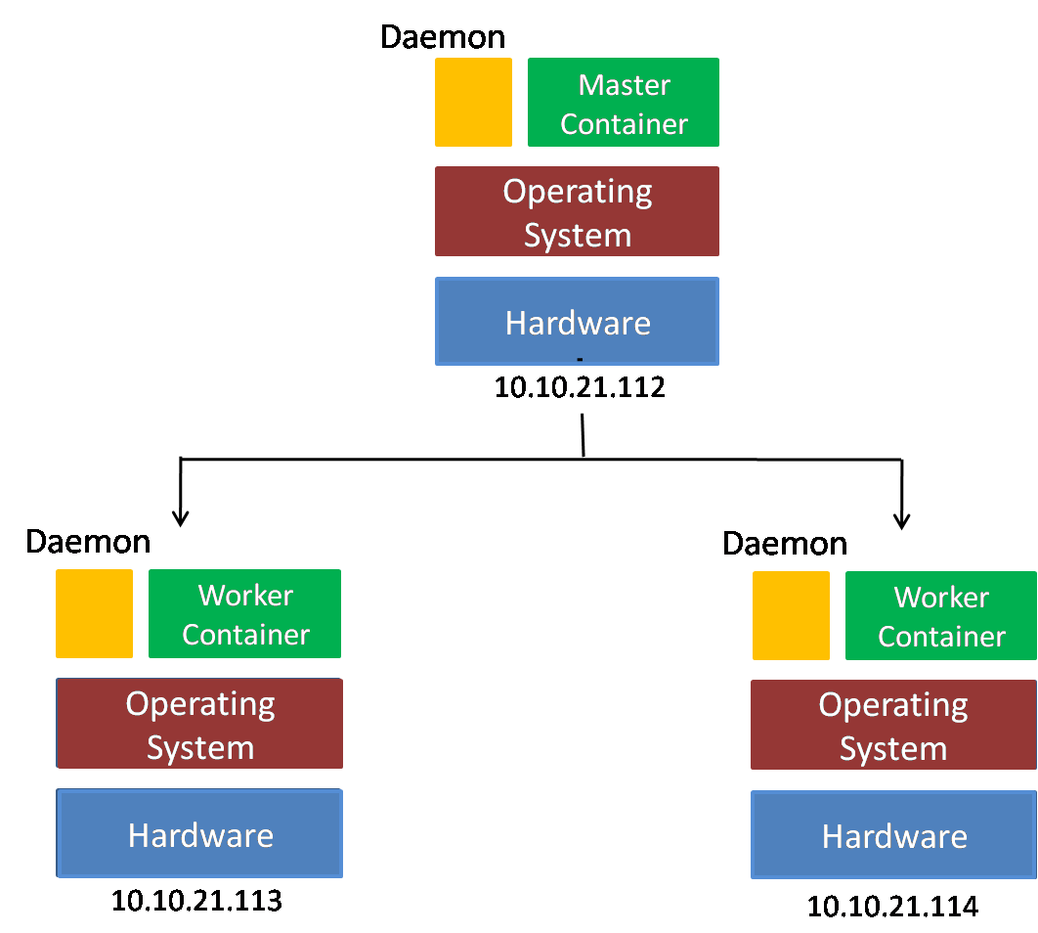

Fig. 4.1 Implemented Aneka Architecture

4.2 Modules Used

4.2.1 Adding a new Machine

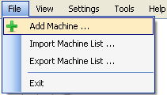

Fig. 4.2.1 Adding Machine in infrastructure

The simplest way to represent your infrastructure in Management Studio is to add each machine individually. You do this by selecting the Add Machine option in the File menu. This approach is simple enough if you have a few machines but can be cumbersome when dealing with a large network or Data Centre.

4.2.2 Repository Management

An Aneka Repository is a location containing all required binaries for installing Aneka Daemons and Containers. When the Aneka Daemon is installed on a machine, the binaries for both the Daemon and the Container are downloaded from the selected repository to a local repository folder in the target machine and installed from there.

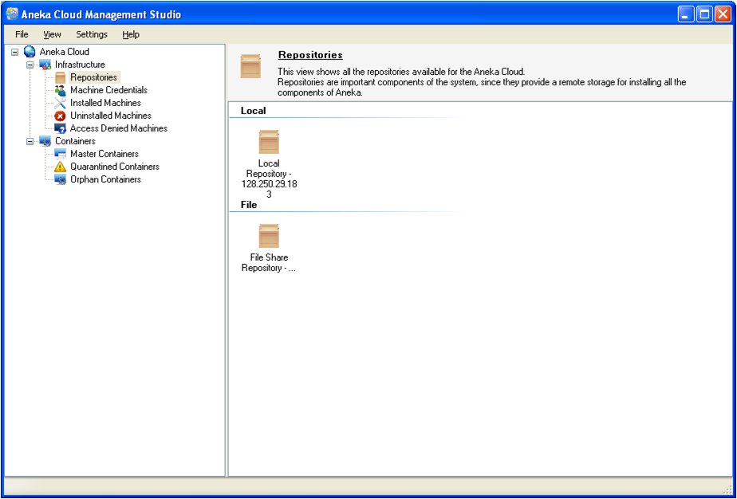 Fig. 4.2.2 Repositories in Aneka

When the Aneka Management Studio is installed on a machine for the first time, a Local Repository is created by default. The local repository is not accessible over the network and can only be used to perform local installations. That is, for installing the Aneka Damon and Containers on the same machine in which the Management Studio is installed.

Creating a new repository is easy and can be done by selecting Add from the context menu for Repositories. The figure below shows the dialog for adding a new repository. The Name field refers to what you would like to call your new repository. Method refers to the mode of access to your repository. The three supported methods include Local, Windows File Share, and FTP. The Access URL refers the location of your repository. In the case of a Local Repository, this would typically refer to Repository folder in your Aneka installation directory. In the case of a Windows File Share Repository the URL must be a network accessible path, in the following form:

Format \\<host>\<drive letter>$\<path>

Example:\\10.10.21.112\C$\ProgramFiles\Manjrasoft\Aneka 2.0\Repository

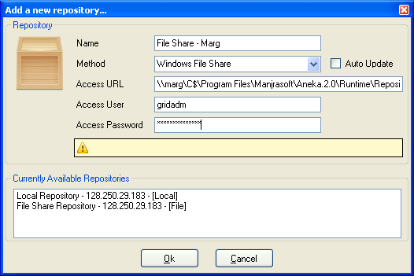

Fig. 4.2.3 Creating Repositories

4.2.3Machine Credentials

The Windows Machine Credentials are the credentials you use to access and manage your remote machines. These include activities such as installing the Aneka Daemon on remote machines, and starting, stopping and uninstalling the Daemon service. These credentials must thus have administrative privileges on the target machine.

When you start up Management Studio for the first time, there will be no credentials defined for you by default. Before you starting managing your infrastructure you must define one or more credentials. To create a new credential select Add from the context menu for Machine Credentials. This will bring up a dialog requesting the user name and password for the credential as show in Figure 4.2.5.

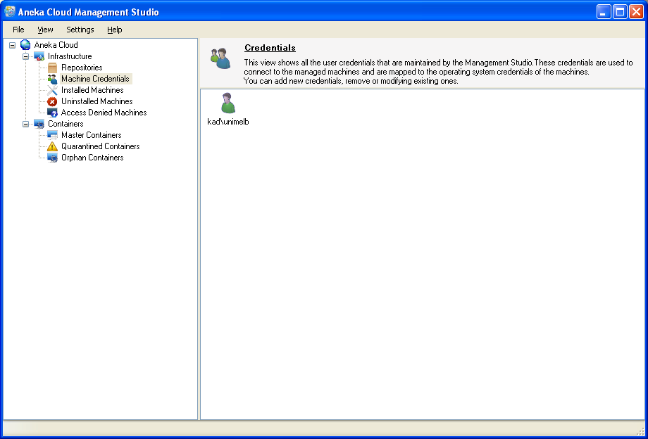 Fig. 4.2.4 Credentials

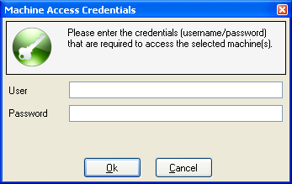

Fig. 4.2.5 Creating New Credentials

As noted earlier, the user account must have administrative rights to the target machine, and can either be a local machine account or a domain account.

4.2.3.1 Access Denied Machines

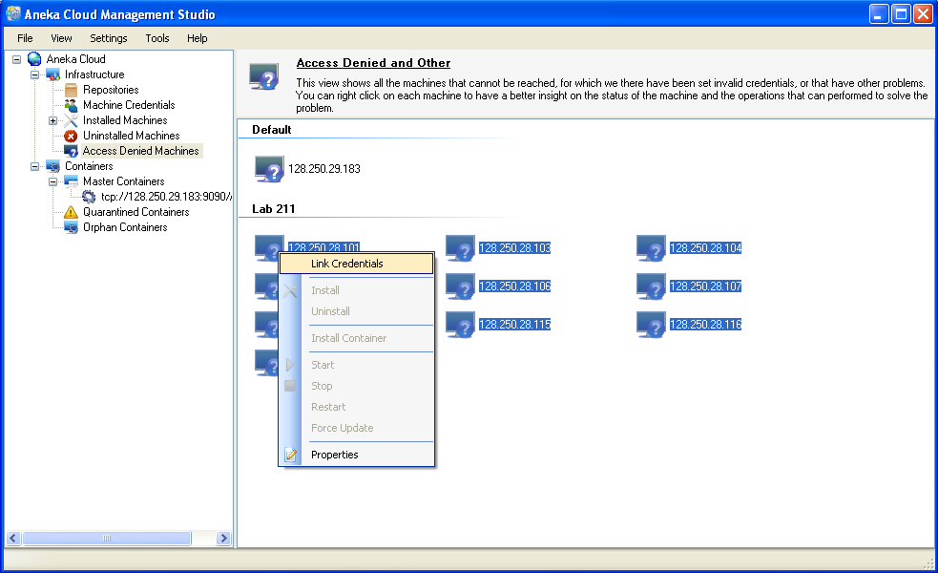 Fig. 4.2.6 Linking Credentials

When you add or import a list of machines for the first time, they will be listed under Access Denied Machines as shown above. This is because the Management Studio does not know what credentials to use to connect to the remote machines. In order to associate a Machine Credential, select all relevant machines and then select Link Credentials from the context menu. This pops up a dialog allowing you to select one of the credentials that you defined earlier, or create a new one if required as shown below.

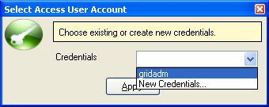

Fig. 4.2.6 Assigning Credentials

4.2.3.2 Uninstalled Machines

An Uninstalled Machine is one which has no Aneka Daemon running. This implies that either Aneka was never installed on the machine or a previous installation was removed. The figure below shows a list of Uninstalled Machines after having linked a valid Machine Credential. It is important to realize that the Management Studio can only determine the status of a machine after linking to a valid credential. To install Aneka Daemons on Uninstalled Machines see section below on installing the Aneka Daemon.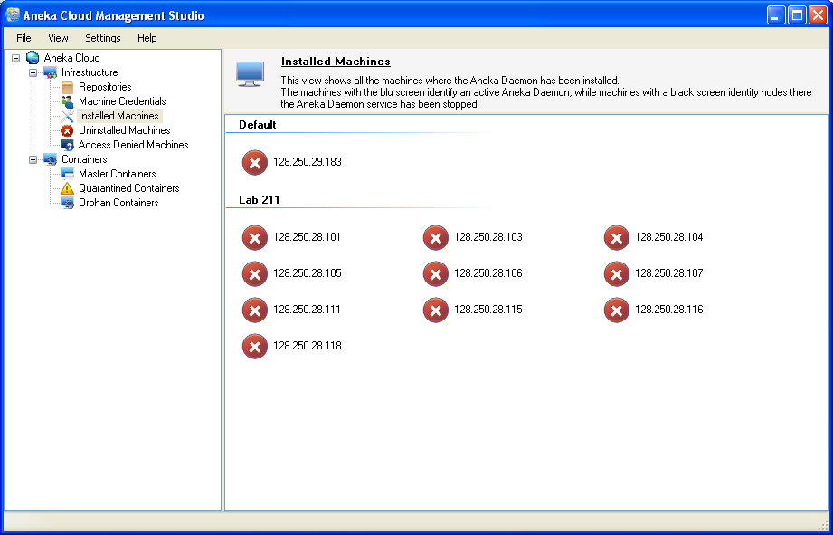 Fig. 4.2.7 Uninstalled Machines

4.2.3.3 Installed Machines

An Installed Machine is one which has an instance of the Aneka Daemon running. An Installed Machine may also have one or more Container instances running. You may perform a number of different activities on an Installed Machine such as starting and stopping the Aneka Daemon service, installing a Container, updating the binaries, viewing the machine’s properties, or uninstalling the Aneka Daemon (and Containers) from the machine. Once you have a collection on Installed Machines at your disposal, you are ready to create your Aneka Cloud.

4.2.4 Installing the Aneka Daemon

The previous sections looked at the process of defining our infrastructure for creating Aneka Clouds. We looked at adding and importing machines, creating *Aneka Repositories* and *Machine Credentials* for performing remote installations, and the various states our machines can be in (*Access Denied*, *Uninstalled*, *Installed*).

This section introduces the process of installing Aneka Daemons, the prerequisite for creating Aneka Clouds. The Aneka Daemon is responsible for managing Aneka Containers that make up our cloud. This includes installing new Containers, starting, stopping and uninstalling Containers. Aneka Daemons provide the underlying management infrastructure for Aneka Clouds. In order to install the Aneka Daemon, select the list of *Uninstalled Machines* that you wish to install the Daemon on, and then select *Install* from the context menu as shown in the figure below. This brings up the *Aneka Daemon Installation Wizard* as shown in the Figure 4.2.8.

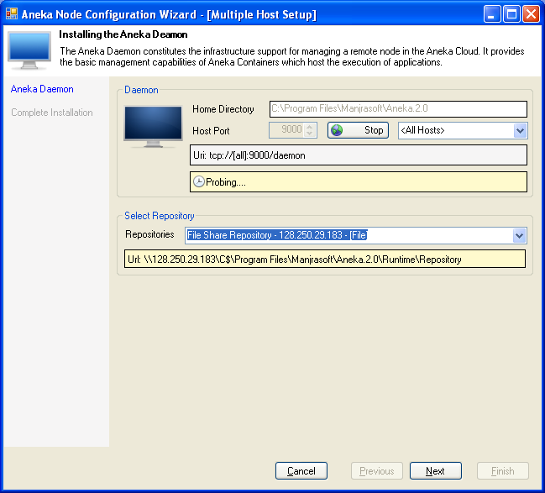

Fig. 4.2.8 Daemon Configuration

Review Summary and Install

Figure 4.2.9 shows a summary of the settings prior to installing the Daemon. If you are satisfied with the installation settings you may start the installation by pressing *Finish*. To change the installation settings press *Previous*.

When you press *Finish* the Wizard will begin installing the Aneka Daemon on all of the selected machines. This process might take a few minutes depending on the number of machines selected. When the Daemons are installed on the target machines they are automatically started up. You might occasionally notice some of the machines being marked with a *warning* icon. This is because the Management Studio is unable to determine the status of the Aneka Daemon on those machines, the most common reason being that the Daemon service might have not finished starting up. Select *Refresh* in the *View* menu after completing the installation in order to see the proper status as shown in the upcoming figures.

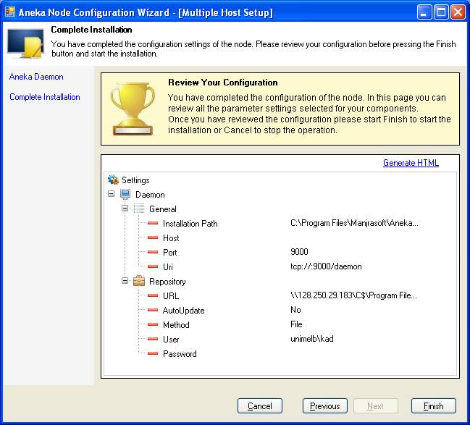

Fig. 4.2.9 Daemon Summary

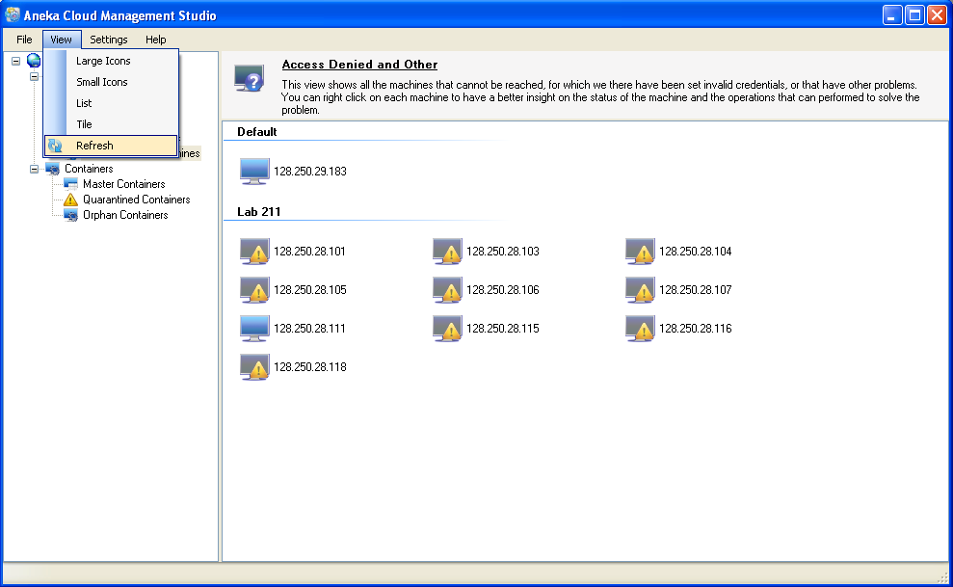

Fig. 4.2.10 Machine Status after Daemon Installation

4.2.5 Creating an Aneka Cloud

Once you have the Aneka Daemon running on all selected machines you are now ready to create an Aneka Cloud. As described earlier, an Aneka Cloud is composed of a *Master Container* and group of *Worker Containers*. All Workers are registered to the Master, which acts as a gateway to the Cloud. End-users submit their applications, composed of a number of jobs, to the Master which in turn schedules them to Workers.

To begin creating your cloud, you must first decide on the machine that will host the *Master Container*. Ideally, this must be a machine capable of processing requests from a number of clients while also managing a large number of Workers. The capability of this machine will of course depend on the size of your cloud and the expected usage. To install the Master Container, select *Install Container* from the context menu on the selected machine, as show in the figure below. This brings up the Container installation Wizard.

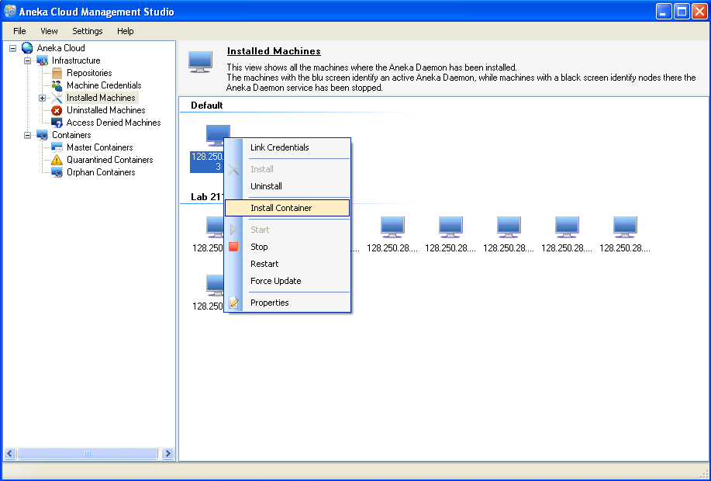

Fig. 4.2.11. Installing the Master Container on the Master Node

4.2.5.1 Installing Master Container

a. Container Type and Port Configuration

The Wizard will automatically probe the default Container port, 9090, on start up in order to verify that it is free. If the port is not free, as a result of being used by another program, you must either ensure that it becomes free, or assign a new port number for the Container. If you wish to verify whether your new port is free, press the Probe button again. Make sure that the selected *Container Type* is *Master* and click *Next* to proceed.

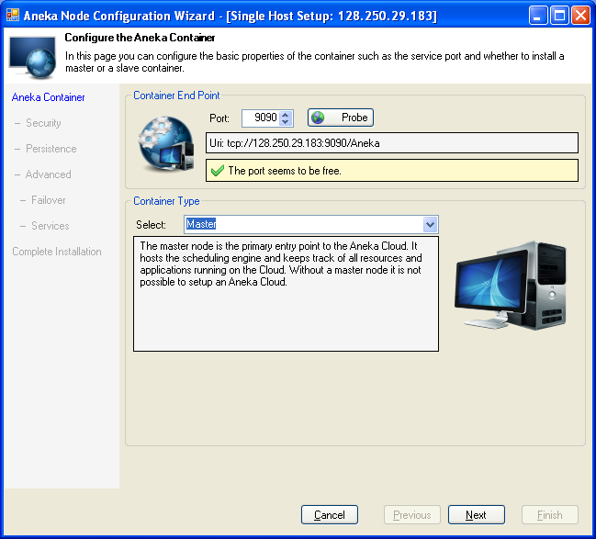

Fig. 4.2.12. Container Type and Node Configuration

b. Security Configuration

This step helps you setup security for your cloud. It is highly recommended that you enable security in a production environment. For testing or evaluation purposes however, you may choose to disable security.

c. Persistence Configuration

An Aneka Cloud maintains data for different purposes including user management, application and job management, resource management, accounting, billing and monitoring to name a few. This step lets you setup the persistence requirements for your cloud.

There are two Persistence Modes available to choose from, Relational Database and

Memory. Memory persistence is typically useful for testing or evaluation purposes, and will store all data in volatile memory which will be lost when the Container restarts or crashes.

d. Service Configuration

This step allows you to select the list of services you wish to host on the Master Container. You may leave the default selection intact for the most common service configuration for the Master Container.

This includes the following list of services:

- ResourceProvisioningService

- TaskScheduler

- ThreadScheduler

- MapReduceScheduler

- StorageService

- LoggingService

- ReportingService

- MonitoringService

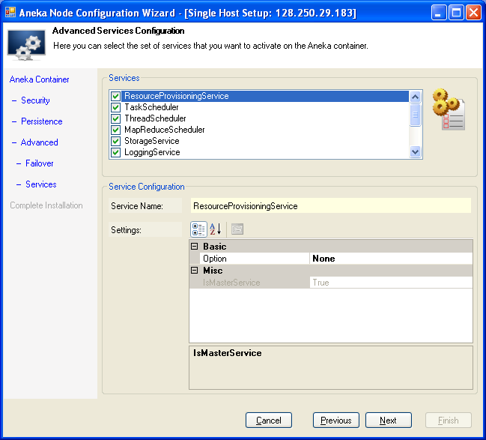

Fig. 4.2.13. Container Service Configuration

e. Summary

The final step of the Wizard presents a summary of the installation settings. Browse through the settings to ensure that everything is correct. In order to change any of the settings click Previous until you reach the corresponding step of the Wizard. To start installing the Container click Finish.

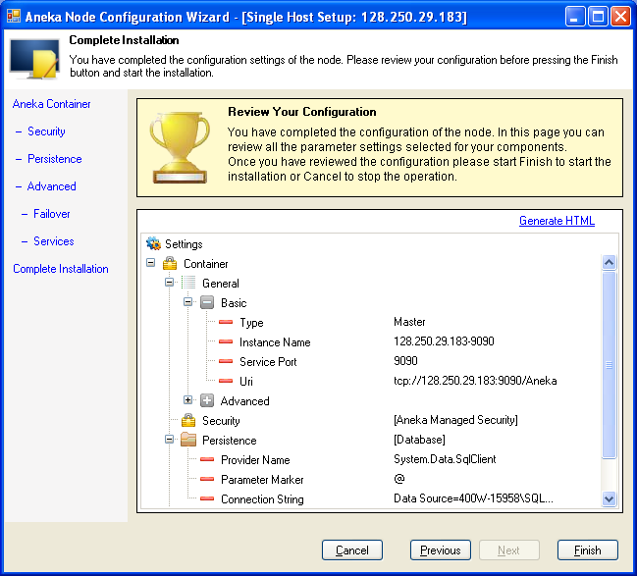

Fig. 4.2.14. Summary of installation

4.2.5.2 Installing Worker Containers

The process of installing Worker Containers is similar to that of installing the Master. Select the list of machines that you wish to install Workers on, and then select Install Container

a. Container Type and Port

Selecting Install Container on the chosen machines brings up the Container Installation Wizard. This Wizard will begin by automatically probing the default Container port, 9090, on all the selected hosts in order to verify that the port is free. If the port is not free, as a result of being used by another program, you must either ensure that it becomes free, or assign a new port number for the Containers. If you wish to verify whether your new port is free, press the Probe button again.

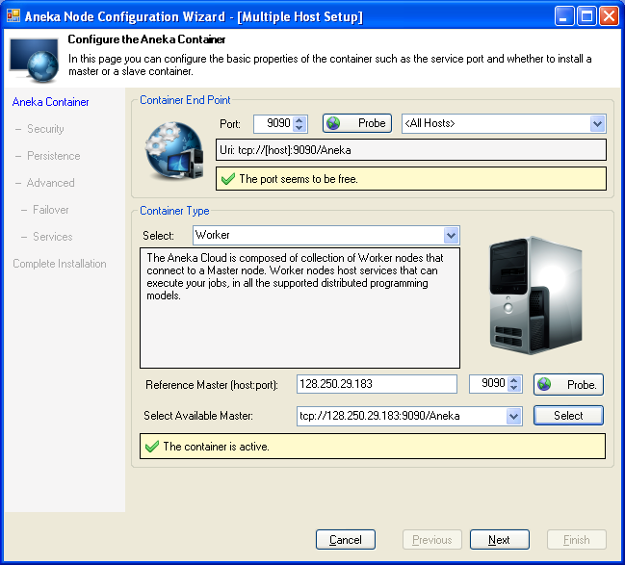

Fig. 4.2.15. Installation of worker container

b. Security Configuration

If you chose to disable security when configuring the Master Container, you must also disable security for your Workers. However, it is highly recommended that you enable security in a production environment. This ensures that the Master and Workers authenticate each other and all traffic exchanged between them is encrypted.

c. Persistence Configuration

No special persistence configuration is required for Workers. Click Next to proceed.

d. Service Configuration

This step allows you to select the list of services you wish to host on the Worker Container. You may leave the default selection intact for the most common service configuration for Worker Containers. This includes the following list of services:

- LoggingService

- MonitoringService

- TaskExecutionService

- ThreadExecutionService

- MapReduceExecutor

e. Summary

The final step of the Wizard presents a summary of the installation settings. Browse through the settings to ensure that everything is correct. In order to change any of the settings click Previous until you reach the corresponding step of the Wizard. To start installing the Container click Finish.

4.3 Performance Results

The performance results obtained in different cases using Aneka are summed below in different cases with their tables and respective graphs.

Case I: The details of cloud configuration for the case I is given below, which is further followed by the data table for power variations in cloud and then its obtained graph.

No of CPU/Nodes: 6/3

Max. Available Power: 12 Ghz

Max memory available: 9.6 GB

Max Storage: 894.27 GB

Table 4.1. Dataset Obtained After Case I

|  |  |  |
| --- | --- | --- |
|  | **Power Available (%)** | **Power Usage (%)** |
| 1 Application | 85.7 | 14.3 |
| 2 Applications | 80.3 | 19.7 |
| 3 Applications | 74 | 26 |

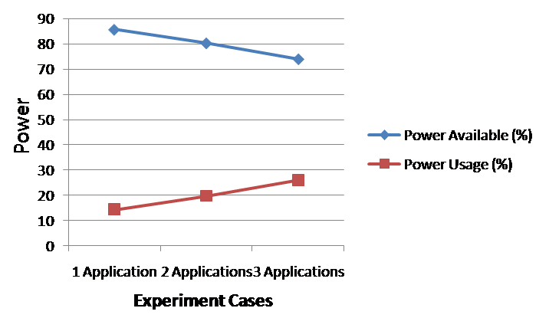

Fig. 4.3.1. Graph for Case I

Case II: The details of cloud configuration for the case II is given below, which is further followed by the data table for power variations in cloud and then its obtained graph.

No of CPU/Nodes: 4/2

Max. Available Power: 8 Ghz

Max memory available: 6.4 GB

Max Storage: 596.18 GB

Table 4.2. Dataset Obtained After Case II

|  |  |  |
| --- | --- | --- |
|  | **Power Available (%)** | **Power Usage (%)** |
| 1 Application | 83.3 | 16.7 |
| 2 Applications | 79.6 | 20.4 |
| 3 Applications | 71.4 | 28.6 |

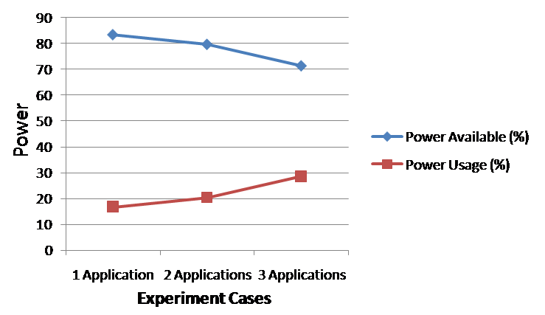

Fig. 4.2.2. Graph for Case II

Case III: The details of cloud configuration for the case III is given below, which is further followed by the data table for power variations in cloud and then its obtained graph.

No of CPU/Nodes: 2/1

Max. Available Power: 4 Ghz

Max memory available: 3.2 GB

Max Storage: 298 GB

Table 4.3. Dataset Obtained After Case III

|  |  |  |
| --- | --- | --- |
|  | **Power Available (%)** | **Power Usage (%)** |
| 1 Application | 82.2 | 17.8 |
| 2 Applications | 79.3 | 20.7 |
| 3 Applications | 70.5 | 29.5 |

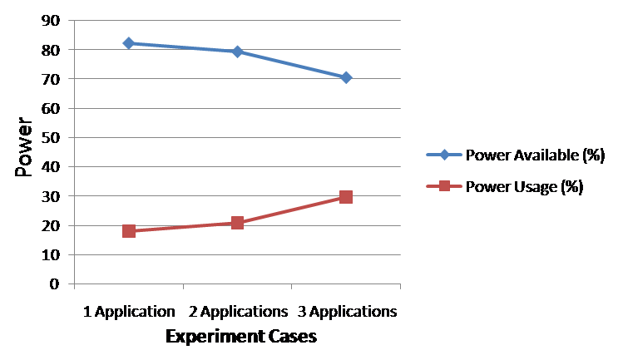

Fig. 4.2.3. Graph for Case III

**Chapter 5**

**Conclusion**

As the development of cloud computing has grown exponentially, performance and security issues have become a top priority.[6] This project report presents the cloud computing technology, a wide application area in cloud computing, cloud computing environment with the security issues and performance through analyzing a cloud computing framework-Aneka. During the experimentation we found that as the number of applications is increasing maximum available power is degrading and there is a noticeable variation in power with change in the cloud resource configuration. Finally we conclude a multiple encryption Ceaser cipher algorithm for data security.

Future Work

We have implemented the multiple encryption solution on Ceaser Cipher only. Thus a wide scope lies for further future work in this domain by implementing this technique on other cryptography solutions. StegnoCrypt can be implemented which upgrades data security to a higher level as it hides even the existence of the message. Thus this project report leaves a wide domain for future works and enhancements in these security solutions.

REFERENCES

[1] Voorsluys, William; Broberg, James; Buyya, Rajkumar, "Introduction to Cloud Computing", New York, USA: Wiley Press. pp. 1–44. ISBN 978-0470887998, 2011.

[2] Sean Marston, Zhi Li “Cloud computing — The business perspective”, Decision Support System, Elsevier, December 2010.

[3] Winkler, Vic “Securing the Cloud: Cloud Computer Security Techniques and Tactics”. Waltham, MA USA: Syngress. pp. 187, 189. ISBN 978-1-59749-592-9, 2011.

[4] D Kyriazis, A Menychtas, G Kousiouris, K Oberle, T Voith, M Boniface, E Oliveros, T Cucinotta, S Berger, “A Real-time Service Oriented Infrastructure”, International Conference on Real-Time and Embedded Systems (RTES 2010), Singapore, November 2010

[5] ChristianVecchiola, Xingchen CHU “Aneka: A Software Platform for

.NET-based Cloud Computing”, www.manjrasoft.com/Case% 20Study_ADRIN_Dept_of_Space.pdf

[6] W. Kim, “Cloud computing: Today and Tomorrow”,Journal of Object Technology 8 (1) (2009)

[7] IDC Enterprise Survey, 2010

[8] Cloud Security Alliance, Security Guidance for Critical Areas of Focus in cloud computing Cloud Security Alliance, 2009

[9]M.A. Vouk, Cloud computing — issues, research and implementations, Journal of

Computing and Information Technology 16 (4) (2008) 235–246.

[10] Barrie Sosinsky, “*Cloud Computing Bible*”, February 2011

[11] Toby Velte, “*Cloud Computing: A practical Approch*”

[12] Rob Lovell, CEO ThinkGrid*, “Introduction to Cloud Computing”*